15: Creating and Testing a Snapshot of a VM Using VMware Workstation
1. Aim
To create a snapshot of a Virtual Machine (VM) using VMware Workstation and test it by restoring the previous version or using a cloned VM.
2. Procedure
- Open VMware Workstation on the host computer.
- Select the required Virtual Machine.
- Start the VM and complete the required configuration.
- Click on VM → Snapshot → Take Snapshot.
- Enter a snapshot name and description.
- Click Take Snapshot to save the current VM state.
- Make some changes to the Virtual Machine.
- Go to VM → Snapshot → Revert to Snapshot.
- Select the previously created snapshot.
- Click Revert to restore the previous VM state.
- Verify that the VM has returned to its earlier version.
IMPLEMENTATION
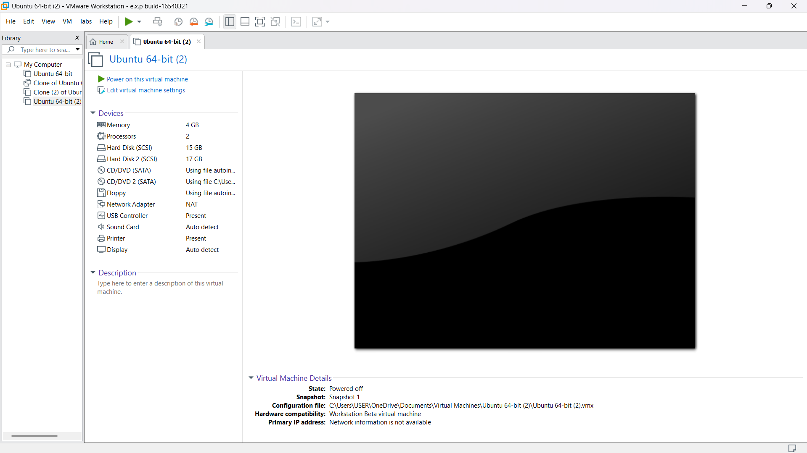

Result
Thus, a snapshot was successfully created in VMware Workstation, and the previous state of the Virtual Machine was restored and tested successfully.

